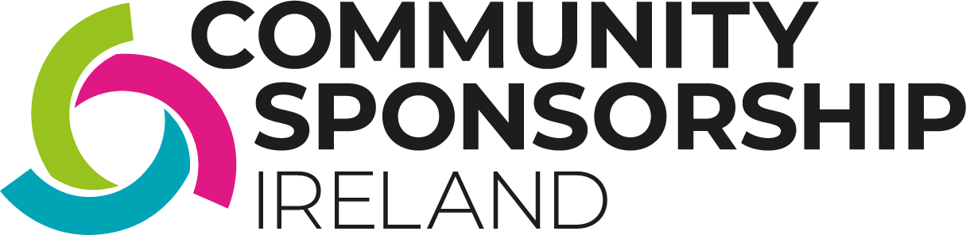

PROTOCOL: PLANNING EFFECTIVE TRANSITIONS
Purpose
The purpose of this protocol is to support Community Sponsorship Groups (CSGs) to plan the ending of the sponsor/sponsored relationship with the individual / family and to formally acknowledge the transition to being neighbours, friends and fellow community members.
Scope
This protocol is for the CSG and families/individuals to consider together in planning for celebration, acknowledgement and next steps at the end of the 18-month sponsorship period.
Rationale
The Community Sponsorship process is an 18-month process during which time the role of the CSG is considered crucial for supporting families new to the community to arrive, settle and navigate their community including the opportunities, services and supports available to them.
This semi-formal relationship is one which essentially frames the family and individuals as beneficiaries of the volunteerism, care and support of a particular group of community members who kindly give of their time, efforts and resources in this relationship. However, the ultimate goal of the CSI Programme is to support individuals and families who resettle here to become full, equal members of their community.
Having a plan for the transition period helps to ensure that this end goal of integration and a move away from a beneficiary/benefactor relationship (if it has emerged that way, this is not a given) is striven for, achieved and acknowledged.
Objectives of Transition Planning
Support Planning
To affirm the change in relationship from sponsor / sponsored to neighbours and friends and what this means in terms of support and relationships, which may include:
- Assessing and acknowledging progress to milestones and identify any outstanding formal supports required for the individual / family to meet their needs
- To prepare for any winding down of formal, material or other supports
- To affirm continued informal support and provide reassurance regarding any concerns the individual / family might have

Celebration
- To acknowledge and celebrate the achievements of the individual or family over the sponsorship period
- To acknowledge and celebrate the community’s work in welcoming the individual or famil
Planning for Change in Supports
Early Acknowledgement:
- From an early point, after initial settling, it should be named and acknowledged that the formal sponsorship relationship is time-limited and has a specific purpose of helping the family to settle in and become part of the community – this is:
o Not to put pressure on anyone, but rather to address any discomfort that may naturally arise for the individual or family as a result of receiving significant amounts of support (emotional, practical or material). Highlighting that the sponsorship period is time-limited may allow the family to feel more comfortable with receiving such support.
o To anticipate and negate the development of a long-term dependent relationship between the family and members of the CSG – a level of dependency is expected and normal during the sponsorship period but the aim of Community Sponsorship is to support self-sufficiency and progress towards mutually beneficial relationships
Planning Transition in Relation to Supports
The CSG and family or individual might agree some goals or milestones to be achieved by the end of the 18-month sponsorship period:
- These goals should be decided by the family, with the CSG identifying what they can do to support achievement of them
- These can be renegotiated regularly in line with progress made, changes in need or ambition
- These should be formally reviewed in anticipation of the transition e.g. 3 months beforehand to review what can be achieved in the time period, and what will happen afterwards (e.g. if a neighbour/friend will continue to support, if they will be linked in with an NGO or statutory provider etc.).
- This should be done in a way that is consultative, led by the family/individual
Particular attention may be required in relation to:
- Any outstanding material support being provided that needs to be wound down
- Housing issues that remain unresolved – a clear plan to either provide continued support in accessing suitable housing or accessing quality support for the individual/family is important
- Supporting the family or individual to ensure they are able to register for and access any necessary mainstream services that are available in their area
- If the conversation has not previously taken place, explaining any cultural norms regarding support and sharing (e.g. people regularly pass on second hand children’s items to friends/ there is a local freecycle group where you can find or pass on clothes, toys etc.)
Celebration
In partnership with the family and in line with their wishes or preferences in relation to socialising, a celebratory event should be organised where all parties have the opportunity to:
- Celebrate the achievements of the last 18 months
- Show gratitude to one another for the support, learning etc.
- Celebrate their full ‘graduation’ into friends, neighbours and community members
This may take the place of a community lunch / barbeque / party or similar.
Protocol last updated: Feb 2022

